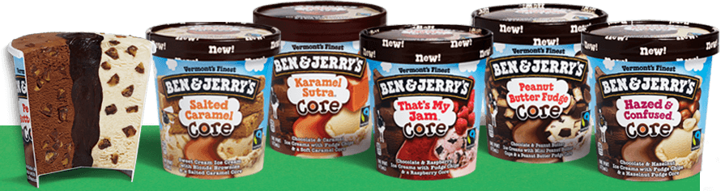
Ben & Jerry’s Ice Cream Lesson on Supply and Demand

Instructions: Visit http://www.benjerry.com/flavors/flavor-graveyard/ and answer the following questions.

- Give a brief description of the history of Ben & Jerry’s:
________________________________________________________________________________________________________________________________________________________________________________________________________________________________________________________________________________________________________________________________________________________

- List the most popular flavor from Ben & Jerry’s:

- List 5 discontinued flavors. List the main ingredients and why you think they are discontinued.

  - ________________________________________________________________________________________________________________________________________________________________
  - ________________________________________________________________________________________________________________________________________________________________
  - ________________________________________________________________________________________________________________________________________________________________
  - ________________________________________________________________________________________________________________________________________________________________
  - ________________________________________________________________________________________________________________________________________________________________

- What is your favorite flavor (any): _________________________________________________

- What is the strangest flavor you saw: ______________________________________________

- What is something unique about Ben & Jerry’s company besides making ice cream that they do or are involved in, etc???

